

SIMATS ENGINEERING
ASSESSMENT TOOL 2: Case Study

COURSE NAME: COMPUTER VISION COURSE CODE: ITA05

COURSE OUTCOME COVERED

CO3: Analyze and extract image features using detection and matching techniques for effective image representation and comparison. (BTL 4)

Assessment Tool Weightage: 20%

Read the given scenario carefully and analyze the problem using appropriate computer vision techniques. Justify your answers with relevant reasoning and comparisons wherever necessary.

1. Preprocessing and Feature Detection
A vision system processes images captured under varying lighting conditions. Without preprocessing, feature detection results are inconsistent.
Analyze the issue and explain how preprocessing improves feature detection performance.
Code:
import cv2
import matplotlib.pyplot as plt

img = cv2.imread("input.jpg", 0)
denoised = cv2.GaussianBlur(img, (5,5), 0)
enhanced = cv2.equalizeHist(denoised)

orb = cv2.ORB_create(nfeatures=500)
kp1, des1 = orb.detectAndCompute(img, None)
kp2, des2 = orb.detectAndCompute(enhanced, None)

print("Keypoints before preprocessing:", len(kp1))
print("Keypoints after preprocessing :", len(kp2))

plt.figure(figsize=(10,4))
plt.subplot(1,2,1)
plt.imshow(cv2.drawKeypoints(img, kp1, None), cmap="gray")
plt.title("Before preprocessing"); plt.axis("off")
plt.subplot(1,2,2)
plt.imshow(cv2.drawKeypoints(enhanced, kp2, None), cmap="gray")
plt.title("After preprocessing"); plt.axis("off")
plt.show()

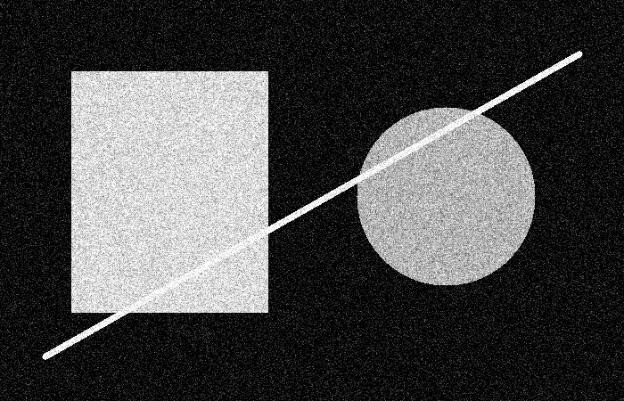

2. Edge vs Corner Detection
In an image containing both straight edges and textured regions, a system uses edge detection but fails to identify key points for matching.
Analyze why edge detection is insufficient and justify the use of corner detection in this case.
Code:
import cv2
import matplotlib.pyplot as plt

img = cv2.imread("input.jpg", 0)
edges = cv2.Canny(img, 100, 200)

corners = cv2.goodFeaturesToTrack(img, 100, 0.01, 10)
out = cv2.cvtColor(img, cv2.COLOR_GRAY2BGR)
if corners is not None:
for c in corners.astype(int):
x,y = c.ravel()
cv2.circle(out, (x,y), 4, (0,255,0), -1)

plt.figure(figsize=(10,4))
plt.subplot(1,2,1); plt.imshow(edges,cmap="gray"); plt.title("Canny Edges"); plt.axis("off")
plt.subplot(1,2,2); plt.imshow(cv2.cvtColor(out,cv2.COLOR_BGR2RGB)); plt.title("Corner Points"); plt.axis("off")
plt.show()
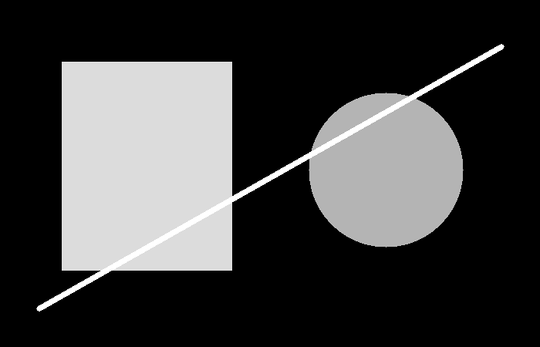

3. Hough Transform in Noisy Images
A system uses Hough Transform to detect lines in noisy images but produces inaccurate results.
Analyze the effect of noise on detection and suggest improvements based on preprocessing or parameter selection.
Code:
import cv2
import numpy as np
import matplotlib.pyplot as plt

img = cv2.imread("input.jpg", 0)
blur = cv2.GaussianBlur(img, (5,5), 0)
edges = cv2.Canny(blur, 50, 150)

lines = cv2.HoughLinesP(edges, 1, np.pi/180, threshold=60,
minLineLength=50, maxLineGap=10)

out = cv2.cvtColor(img, cv2.COLOR_GRAY2BGR)
if lines is not None:
for line in lines:
x1,y1,x2,y2 = line[0]
cv2.line(out,(x1,y1),(x2,y2),(0,255,0),2)

plt.imshow(cv2.cvtColor(out,cv2.COLOR_BGR2RGB))
plt.title("Hough Line Detection after Denoising")
plt.axis("off"); plt.show()

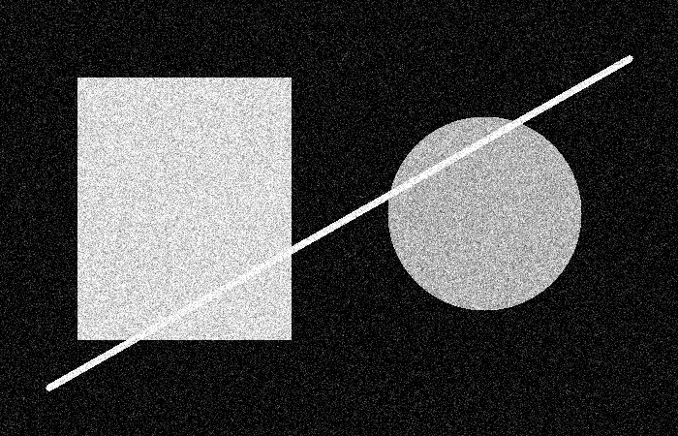

4. Feature Matching under Transformations
Two images of the same object are taken at different scales and orientations. Traditional feature matching fails, but scale invariant feature matching works effectively.
Analyze why scale invariant methods perform better in this scenario.

Code:
import cv2
import numpy as np

# Create a sample reference image
img1 = np.zeros((500, 700), dtype=np.uint8)

cv2.rectangle(img1, (150, 100), (500, 400), 255, 5)
cv2.circle(img1, (325, 250), 80, 255, 5)
cv2.line(img1, (150, 100), (500, 400), 255, 4)
cv2.line(img1, (500, 100), (150, 400), 255, 4)

# Create a transformed version:
# rotation + scaling
center = (350, 250)
matrix = cv2.getRotationMatrix2D(center, 30, 1.3)

img2 = cv2.warpAffine(
img1,
matrix,
(700, 500)
)

# SIFT
sift = cv2.SIFT_create()

kp1, des1 = sift.detectAndCompute(img1, None)
kp2, des2 = sift.detectAndCompute(img2, None)

print("Reference image keypoints:", len(kp1))
print("Transformed image keypoints:", len(kp2))

# Match descriptors
bf = cv2.BFMatcher()

matches = bf.knnMatch(des1, des2, k=2)

# Lowe's ratio test
good_matches = []

for m, n in matches:
if m.distance < 0.75 * n.distance:
good_matches.append(m)

print("Good scale/rotation invariant matches:",
len(good_matches))

# Draw matches
result = cv2.drawMatches(
img1,
kp1,
img2,
kp2,
good_matches,
None,
flags=cv2.DrawMatchesFlags_NOT_DRAW_SINGLE_POINTS
)

cv2.imwrite(
"04_scale_rotation_matching_result.png",
result
)

cv2.imshow(
"SIFT Scale and Rotation Invariant Matching",
result
)

cv2.waitKey(0)
cv2.destroyAllWindows()

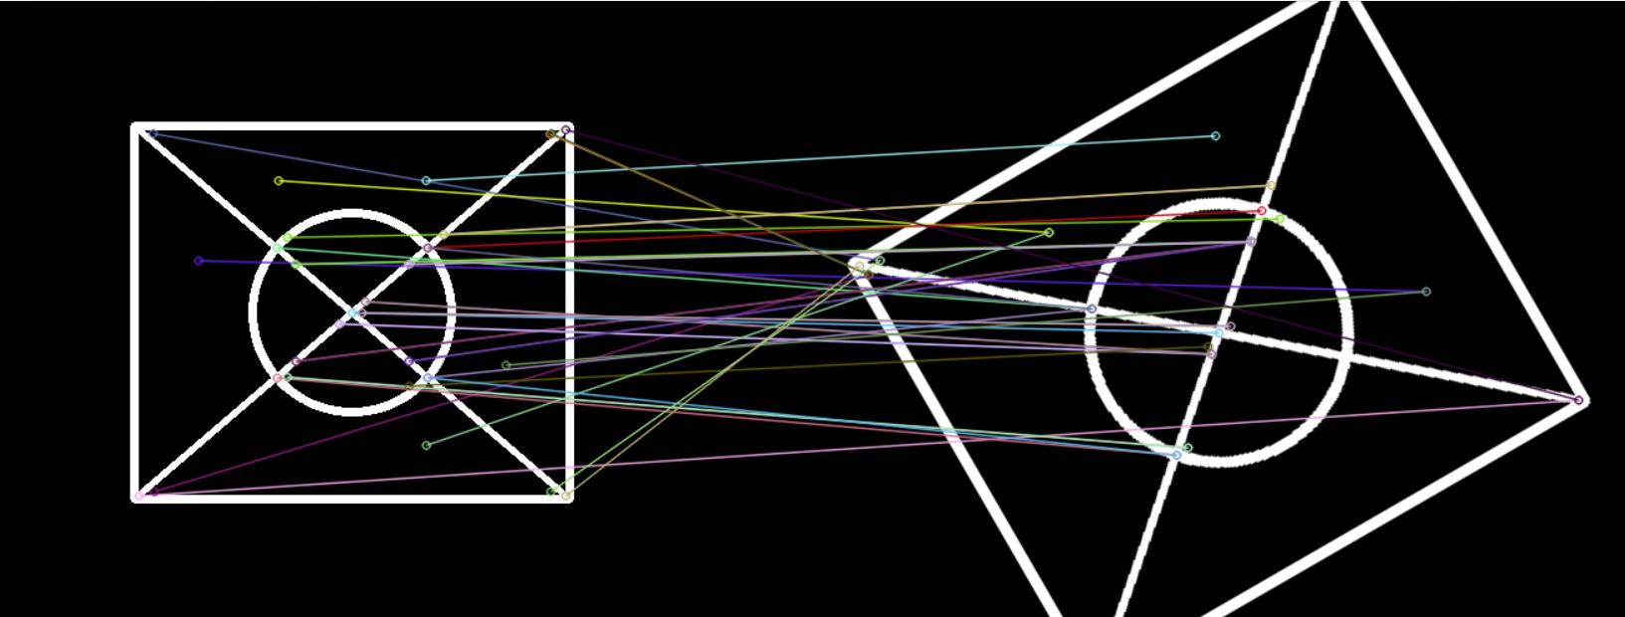
5. PCA for Feature Optimization
A system extracts a large number of features, leading to high computational cost and redundancy.
Analyze how Principal Component Analysis helps in reducing dimensionality and improving efficiency.
Code:
import cv2
import numpy as np
from sklearn.decomposition import PCA
from sklearn.datasets import load_digits
import matplotlib.pyplot as plt

X, y = load_digits(return_X_y=True)

pca = PCA(n_components=0.95)
X_reduced = pca.fit_transform(X)

print("Original dimensions :", X.shape[1])
print("Reduced dimensions :", X_reduced.shape[1])
print("Variance retained :", pca.explained_variance_ratio_.sum())

plt.plot(np.cumsum(pca.explained_variance_ratio_))
plt.xlabel("Number of components")
plt.ylabel("Cumulative explained variance")
plt.grid()
plt.show()

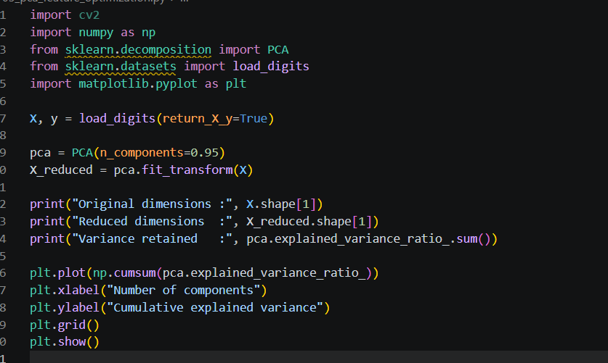

6. Preprocessing Impact on Edge Detection
A system performs edge detection on raw images containing noise and uneven illumination, resulting in fragmented edges.
Analyze the problem and explain how preprocessing improves edge detection accuracy and continuity.
Code:
import cv2
import matplotlib.pyplot as plt

img = cv2.imread("input.jpg", 0)
denoised = cv2.GaussianBlur(img, (5,5), 0)
clahe = cv2.createCLAHE(clipLimit=2.0, tileGridSize=(8,8))
enhanced = clahe.apply(denoised)

raw_edges = cv2.Canny(img, 50, 150)
clean_edges = cv2.Canny(enhanced, 50, 150)

plt.figure(figsize=(10,4))
plt.subplot(1,2,1); plt.imshow(raw_edges,cmap="gray"); plt.title("Raw Image Edges"); plt.axis("off")
plt.subplot(1,2,2); plt.imshow(clean_edges,cmap="gray"); plt.title("Preprocessed Edges"); plt.axis("off")
plt.show()
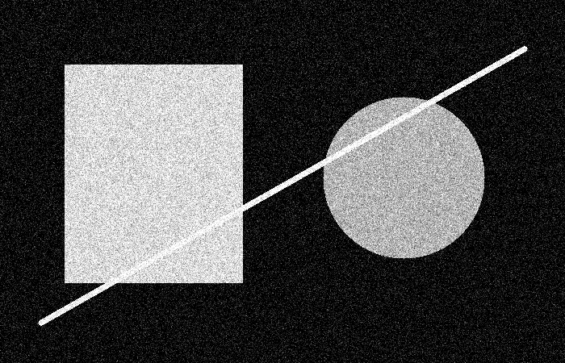

7. Corner Detection vs Edge Detection in Tracking
A tracking system uses edge detection but fails to track moving objects accurately across frames.
Analyze why edges are insufficient and justify the use of corner detection for reliable tracking.
Code:
import cv2

cap = cv2.VideoCapture(0)
old_gray = None
old_pts = None

while True:
ret, frame = cap.read()
if not ret: break

gray = cv2.cvtColor(frame, cv2.COLOR_BGR2GRAY)

if old_pts is None:
old_pts = cv2.goodFeaturesToTrack(gray, 100, 0.01, 10)
old_gray = gray.copy()
else:
new_pts, status, _ = cv2.calcOpticalFlowPyrLK(
old_gray, gray, old_pts, None
)
if new_pts is not None:
for p,n,s in zip(old_pts, new_pts, status):
if s:
x,y = n.ravel().astype(int)
cv2.circle(frame,(x,y),4,(0,255,0),-1)
old_pts = new_pts[status==1].reshape(-1,1,2)
old_gray = gray.copy()

cv2.imshow("Corner Tracking", frame)
if cv2.waitKey(1) & 0xFF == 27: break

cap.release(); cv2.destroyAllWindows()

8. Hough Transform for Shape Detection
A system uses Hough Transform to detect circular shapes but fails in complex backgrounds.
Analyze the limitations and explain how preprocessing or parameter tuning can
Code:
improve detection. import cv2
import numpy as np
import matplotlib.pyplot as plt

img = cv2.imread("input.jpg", 0)
blur = cv2.medianBlur(img, 5)

circles = cv2.HoughCircles(
blur, cv2.HOUGH_GRADIENT, dp=1.2, minDist=30,
param1=100, param2=30, minRadius=10, maxRadius=150
)

out = cv2.cvtColor(img, cv2.COLOR_GRAY2BGR)
if circles is not None:
circles = np.uint16(np.around(circles))
for x,y,r in circles[0,:]:
cv2.circle(out,(x,y),r,(0,255,0),2)
cv2.circle(out,(x,y),2,(0,0,255),3)

plt.imshow(cv2.cvtColor(out,cv2.COLOR_BGR2RGB))
plt.title("Hough Circle Detection")
plt.axis("off"); plt.show()


9. Feature Matching under Illumination Changes
Two images of the same scene are captured under different lighting conditions, causing feature matching errors.
Analyze why matching fails and explain how preprocessing or robust descriptors improve performance.
Code:
import cv2
import numpy as np

# --------------------------------------------------
# Create a sample scene
# --------------------------------------------------

img1 = np.zeros((500, 700), dtype=np.uint8)

# Objects in the scene
cv2.rectangle(img1, (120, 100), (580, 400), 180, -1)
cv2.rectangle(img1, (170, 150), (530, 350), 80, -1)
cv2.circle(img1, (350, 250), 90, 220, -1)

# Add some lines and shapes for feature points
cv2.line(img1, (120, 100), (580, 400), 255, 4)
cv2.line(img1, (580, 100), (120, 400), 255, 4)
cv2.rectangle(img1, (220, 180), (300, 260), 200, -1)

# --------------------------------------------------
# Create second image with different illumination
# --------------------------------------------------

# Make image darker
img2 = cv2.convertScaleAbs(
img1,
alpha=0.55,
beta=20
)

# Add slight brightness variation
illumination = np.zeros_like(img2)
cv2.circle(illumination, (550, 100), 250, 50, -1)

img2 = cv2.add(img2, illumination)

# --------------------------------------------------
# Apply CLAHE
# --------------------------------------------------

clahe = cv2.createCLAHE(
clipLimit=2.0,
tileGridSize=(8, 8)
)

img1_enhanced = clahe.apply(img1)
img2_enhanced = clahe.apply(img2)

# --------------------------------------------------
# SIFT Feature Detection
# --------------------------------------------------

sift = cv2.SIFT_create()

kp1, des1 = sift.detectAndCompute(
img1_enhanced,
None
)

kp2, des2 = sift.detectAndCompute(
img2_enhanced,
None
)

print("Keypoints in Image 1:", len(kp1))
print("Keypoints in Image 2:", len(kp2))

# --------------------------------------------------
# Feature Matching
# --------------------------------------------------

matcher = cv2.BFMatcher()

matches = matcher.knnMatch(
des1,
des2,
k=2
)

# Lowe's Ratio Test
good_matches = []

for m, n in matches:
if m.distance < 0.75 * n.distance:
good_matches.append(m)

print(
"Good matches after illumination normalization:",
len(good_matches)
)

# --------------------------------------------------
# Draw Matching Result
# --------------------------------------------------

result = cv2.drawMatches(
img1_enhanced,
kp1,
img2_enhanced,
kp2,
good_matches,
None,
flags=cv2.DrawMatchesFlags_NOT_DRAW_SINGLE_POINTS
)

# Save result
cv2.imwrite(
"09_illumination_matching_result.png",
result
)

print(
"Result saved as: 09_illumination_matching_result.png"
)

# Display result
cv2.imshow(
"Feature Matching under Illumination Changes",
result
)

cv2.waitKey(0)
cv2.destroyAllWindows()
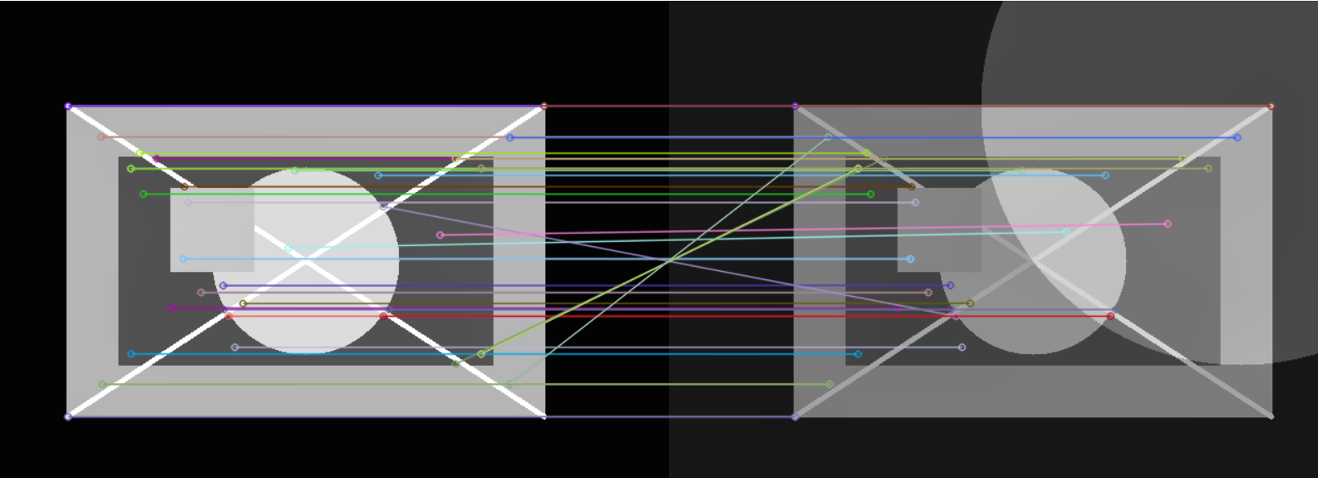

10. PCA in Face Recognition
A face recognition system processes high-dimensional image data, resulting in slow performance.
Analyze how PCA helps in reducing dimensionality while preserving important features.

11. Edge Detection in Low Contrast Images
An image has low contrast, causing edge detection algorithms to fail.
Analyze the problem and explain how preprocessing enhances edge detection results.
Code:
import cv2
import matplotlib.pyplot as plt

img = cv2.imread("input.jpg", 0)

clahe = cv2.createCLAHE(clipLimit=2.0, tileGridSize=(8,8))
enhanced = clahe.apply(img)

edges_before = cv2.Canny(img, 50, 100)
edges_after = cv2.Canny(enhanced, 50, 100)

plt.figure(figsize=(10,4))
plt.subplot(1,2,1); plt.imshow(edges_before,cmap="gray"); plt.title("Before Contrast Enhancement"); plt.axis("off")
plt.subplot(1,2,2); plt.imshow(edges_after,cmap="gray"); plt.title("After CLAHE"); plt.axis("off")
plt.show()



12. Corner Detection in Textured Regions
A system applies corner detection in highly textured regions, resulting in excessive keypoints.
Analyze the issue and suggest methods to improve feature selection.

13. Feature Matching with Noise
Feature matching between two images fails due to noise in one image.
Analyze the impact of noise and explain how preprocessing improves matching accuracy.

14. PCA and Information Loss
A system applies PCA aggressively and loses important feature details.
Analyze the trade-off between dimensionality reduction and information loss, and justify optimal component selection.

15. Combined Feature Detection and Matching
A system detects features correctly but fails during matching due to incorrect descriptor selection.
Analyze the issue and explain how appropriate feature descriptors improve matching performance.

Code of Conduct:

I B. Pranay Deep Chowdary / 1924272177 (Name / Reg No) certify that this submission is my original work and that I have adhered to the guidelines specified for this assessment.
I understand that any violation of academic integrity rules will result in disciplinary action.

Signature of the student: B. Pranay Deep Chowdary

RUBRICS FOR CALCULATION:

Criteria | Weightage | Level 4 – Exemplary | Level 3 – Proficient | Level 2 – Developing | Level 1 – Beginning
Understanding of Case | 25 | Thorough understanding; clearly identifies all key issues | Good understanding with most issues identified | Basic understanding; some issues missed | Poor understanding; problem not identified correctly
Application of Concepts | 25 | Effectively applies relevant concepts to analyze the case deeply | Applies appropriate concepts with minor gaps | Limited application of concepts | Fails to apply relevant concepts
Analysis | 20 | In-depth analysis with strong reasoning and insights | Good analysis with logical reasoning | Basic analysis with limited depth | Weak or no analysis; lacks reasoning
Solution Design | 20 | Innovative, feasible solutions with strong justification | Logical solutions with adequate justification | Basic solutions with weak justification | Incorrect or no solution provided
Clarity | 10 | Clear, well-structured, and easy to understand | Organized and understandable presentation | Limited clarity and structure | Poor clarity; difficult to understand

